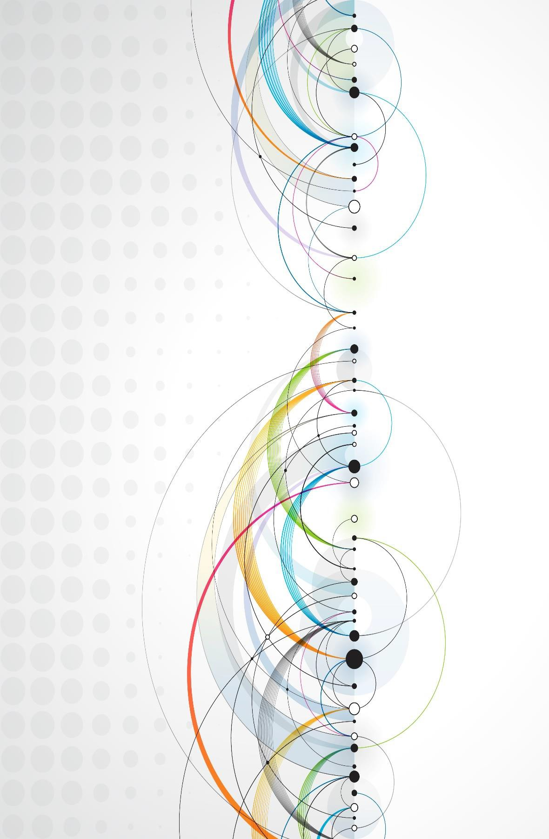
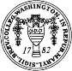
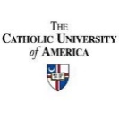
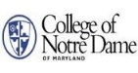
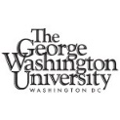
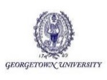
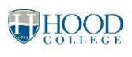
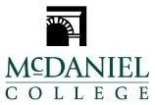
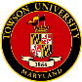
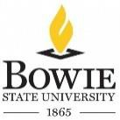
April 22, 2017

Phi Alpha Theta
Mid-Atlantic
Regional
Conference
University
of
Baltimore
Baltimore, MD

Participating Institutions:

Phi Alpha Theta (ΦΑΘ) is an American honor society for undergraduate and graduate students and professors of history. The society has over 350,000 members, with about 9,500 new members joining each year through 860 local chapters.
2017

Phi Alpha Theta was established on March 17, 1921 at the University of Arkansas by Professor Nels Cleven. Cleven had become convinced in his time at the university that a fraternity of scholars (which would accept men or women) was important for the study of history. He invited students to a meeting to form the society (then called the “University Historical Society”) on March 14, and the society was officially recognized on the 17th. In April, the decision was made for the society to be known by the Greek letters Phi

Alpha Theta.

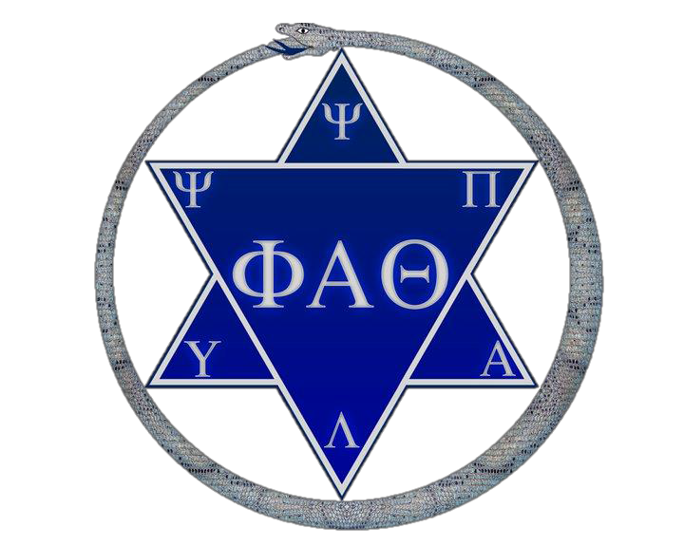

8:00 AM – 9:00 AM Registration and Breakfast
Atrium, William H. Thumel Sr. Business Center (BC)
PANEL SESSION 1 9:00 AM – 10:30 AM

BC 205: Dire Realities during World War I Panel 1
Benjamin Snyder, Towson University
“The Impact of Food Shortages during World War I”

Sophia Zahner, Towson University
“The History of Chemical Warfare in World War I”

Comment: Dr. Clayton Black Moderator: St. Mary's College of Maryland

BC 207: American Women’s Activism before the Vote Panel 2
Rebecca McCarron, The Catholic University of America
“Elizabeth Van Lew, a Citizen without a Vote: Exploring Race and Gender during the Civil War and Reconstruction”

Lucy Benson, McDaniel College
“The Impracticality of Dress: Gilman’s ‘The Dress of Women’”

Carrie Nevius, McDaniel College
“Conformity and Rebellion: Female Students at the Carlisle Indian Industrial School”

Zoie McNeill, McDaniel College
“Ida B. Wells’ Crusade against Lynch Law: Gender and Racial Politics in the New South
From 1890 to 1920”

Comment: Dr. Betsy Nix, University of Baltimore

BC 219: Legacies of Imperialism Panel 3

Gregory I. Foster, Bowie State University

“When the Sun Set on Britannia: The Loss of Great Britain’s Empire in

Southeast Asia during World War II”

Sam Kebede, Hood College
“The Indigeneity of the Oromo of East Africa”
Jacqueline Mangogna, Hood College
“The Rapa Nui”

Comment: Dr. Boram Yi, University of Baltimore

We Hope You enjoyed the 2017 Phi Alpha Theta Mid- Atlantic Regional Conference!

- The University of Baltimore
Division of Legal, Ethical and Historical Studies

The University of Baltimore provides innovative education in business, public affairs, the applied liberal arts and sciences, and law to serve the needs of a diverse population in an urban setting. A public university, the University of Baltimore offers excellent teaching and a supportive community for undergraduate, graduate and professional students in an environment distinguished by academic research and public service.

The Division of Legal, Ethical and Historical Studies (LEHS) in UB's College of Arts and Sciences offers a variety of undergraduate and graduate degree programs, including the premier prelaw programs at UB. Majoring in one of our LEHS programs – either History, Jurisprudence or Philosophy, Society and Applied Ethics – students can develop an understanding of both law and the history, philosophy, and ethics behind it. The history faculty in LEHS wish to give a special thanks to the College of Arts & Sciences Dean Chris Spencer, Dr. Jamie Gianoutsos, Dr. Linda Ruggles, and Dr. Jack Tunstall at Phi Alpha Theta. The 2017 Mid-Atlantic conference would not have been possible without their support.

BC 219: A Medieval and Early Modern Atlantic World Panel 11
Sam Fearnside, The Catholic University of America
“Compromise and Social Evolution: The Christianization of Iceland, 1000-1262

Joseph Albanese, George Washington University
Cloths, Cracks, and Catholics: Mary I’s Consolidation of Power through Portraiture and Ceremonial

Daniel Cooley, The Catholic University of America
“The Norris-Drake Expedition of 1587 and Elizabethan Foreign Policy”

Comment: Dr. Linda Ruggles, University of Maryland University College

BC 319: Great Moments in American Leadership Panel 12
Benjamin England, McDaniel College
“Douglas’s Struggle with the Declaration of Independence: The Lincoln-Douglas Debates, 1858”

Elizabeth Shearin, Hood College
“Eisenhower and Desegregation: Personal Morality or Executive Responsibility?”

Comment: Dr. Boram Yi, University of Baltimore

4:15 PM Awards and Closing Ceremony
Auditorium, William H. Thumel Sr. Business Center (BC)

BC 319: Restarting the Great War in Europe Panel 4
Ray Cwiklinski, Washington College
“Ezra Pound and the Lure of Fascism”

Tanner Jackson, The Catholic University of America
“Italian Chemical Weapons Use during the Second Italo-Abyssinian War, 1935-36

Matthew Boyle, McDaniel College
“Deal Between Devils: The Molotov-Ribbentrop Pact and Its Interpretations”

Comment: Dr. George S. Sochan, Bowie State University

10:30 AM – 10:45 AM Short Break

PANEL SESSION 2 10:45 AM – 12:15 PM

BC 205: The Fate of Nations during World War I Panel 5
Ashley Stanislaus, Towson University
“What Is Belgian Neutrality and How Was It Violated?

Steven Naughton, Towson University
“French Politicians Facing the Fire”

James L. Abdu, McDaniel College
“Changing Interpretations of the Collapse of Austria-Hungary: Nationalisms, State Building, Internal Conflicts, and Viability

Comment: Dr. Nicole Hudgins, University of Baltimore

BC 207: Lost Worlds Panel 6
Samuel DeWitt Pfister, George Washington University
“Monumental and Diplomatic: The Role of the Megiddo Great Temple in Egyptian Hegemony”

Juliette White, McDaniel College
“The Role of Religion in the Conquest of the Aztec Empire”

Comment: Dr. Alexander Pavuk, Morgan State University

BC 219: The American Revolutionary Era Panel 7
Cory Glocker, McDaniel College
“Frontier Diplomat: George Croghan in the French and Indian War, 1750-1763”

Andrea Marshall, George Washington University
“Scotland and the American Revolution: How a Divided Country Influenced America’s Independence”

Kathryn White, George Washington University
“An American Icon through the Ages: Depictions of George Washington in the Collection of the George Washington University Museum”

Eric Burroughs, Towson University
“Thomas Jefferson’s Influences on James Monroe’s Presidency”

Comment: Dr. Jeffrey Sawyer, University of Baltimore

BC 319: The Discourse of Guilt since World War II Panel 8
Melissa Golowski, McDaniel College
“A Regent without a King, an Admiral without a Fleet, and a Historiography without Consensus: Hungary’s role in World War II”

Annie Wade, The Catholic University of America
“The Missing Front Page: The American Press and the Holocaust, 1941-1945”

Kiki Shim, Georgetown University
“Diaspora Negation and the Israeli Holocaust Narrative: An Analysis of the Holocaust in Israeli Public Discourse in the 1950s”

Comment: Dr. Charles Holden, St. Mary’s College of Maryland

12:15 PM – 1:00 PM Lunch
Atrium, William H. Thumel Sr. Business Center (BC)

1:00 PM – 2:00 PM Keynote Address
Atrium, William H. Thumel Sr. Business Center (BC)

“Bodies on the Line for Freedom”
Dr. Francesca P. Gamber, Head of the Early College, Bard High School Early College Baltimore

2:00 PM – 2:30 PM Break and Faculty Advisors’ Meeting
BC 321

PANEL SESSION 3 2:30 PM – 4:00 PM

BC 205: The History of Alternative Music Panel 9
Mark Chandler, The Catholic University of America
“Jazz and Ragtime: Their Reception and Appeal to White Audiences”

Jarrett L. Hoffman, Bowie State University
“Jazz: A Gateway to Success during the Black Renaissance”

J.R. Rhine, St. Mary’s College of Maryland
“Out of Step: Straight Edge, Hardcore Punk Rock, and the Rebellion against Malaise in 1980s Washington, D.C."

Comment: Dr. Tamara Brown, Bowie State University

BC 207: Postwar American Social History Panel 10
Erica Fuller, The Catholic University of America
“The Sylvia Likens Case and Media Coverage of Child Abuse in America”

Matthew Jeffers, St. Mary’s College of Maryland
"Elephants in Suburbia: Executive Power and Republicanism in 1970s Montgomery County"

Jesse Guttman, McDaniel College
“The Recovered History of Search and Rescue in the Mid-Atlantic: The Creation of the Appalachian Search and Rescue Conference”

Comment: Dr. Betsy Nix, University of Baltimore

